**Air Quality monitoring System**

**A Project Report**

*Submitted in the partial fulfillment for the award of the degree of*

**BACHELOR OF ENGINEERING**

**IN**

**COMPUTER SCIENCE WITH SPECIALIZATION IN**

**DEVOPS**

**Submitted by:**

UID-22BDO10074

NAME-SANDHYA KUMARI

**Under the Supervision of:**

**GEETANJALI PANDEY**



**CHANDIGARH UNIVERSITY, GHARUAN, MOHALI - 140413,**

**PUNJAB**

**January-May (2024)**

# Abstract

Air pollution is a growing issue these days. It is necessary to monitor air quality and keep it under control for a better future and healthy living for all. Here we propose an air quality as well as sound pollution monitoring system that allows us to monitor and check live air quality in particular areas through IOT. System uses air sensors to sense presence of harmful gases/compounds in the air and constantly transmit this data to microcontroller, also system keeps measuring sound level and reports it to the online server over IOT. The sensors interact with microcontroller which processes this data and transmits it over internet. This allows authorities to monitor air pollution in different areas and take action against it. This project gives a proposal for addressing the issue of indoor air quality using the internet of things communication model. The description of the effects of low moderate levels of pollutants on the occupants on the indoor space is presented. A system, containing sensor networks and being internet of things enabled, is proposed, to facilitate in achieving efficient indoor air quality system. The system is designed to contain three major areas of functionality: first, the wireless sensor network that will provide the pollutant levels of the room. Second, this information is passed through a wireless access point and gets dumped on a server machine. Third, the server -side stores and processes this data. The server side contains user interface and notification system functionalities.

* **Keywords:** Internet-of-things (IoT), Air quality monitoringPM2.5, cloud

# Table of Contents

|  |  |
| --- | --- |
| Title Page | 1 |
| Abstract | 2-3 |
| 1.    Introduction | 4 |
| 1.1  Problem Definition | 5 |
| 1.2 Project Overview | 6 |
| 1.3 Hardware Specification | --- |
| 1.4 Software Specification | --- |
| 2.    Literature Survey | 7 |
| 2.1 Existing System | 8 |
| 2.2 Proposed System | --- |
| 2.3 Literature Review Summary | 9 |
| 3.    Problem Formulation | 10 |
| 4.    Research Objective | 11 |
| 5.    Methodologies | 12 |
| 6.    Experimental Setup | --- |
| 7.     Conclusion | 13 |
| 8.    Tentative Chapter Plan for the proposed work | 14 |
| 9.    Reference | 15 |
|  |  |

# 1. INTRODUCTION

There has been an increase in public and government attention to air pollution in developing countries as a result of rapid industrialization and transportation growth.

Because air pollution has detrimental effects on human health, environmental sustainability, and quality of life, it has attracted more attention in recent years. Strong air quality monitoring systems are becoming more and more necessary as global urbanization and industries grow. Conventional monitoring techniques frequently have shortcomings such incomplete coverage, sluggish data processing, and inability to scale. Adoption of cloud-based solutions that make use of cutting-edge technology like data analytics, cloud computing, and the Internet of Things (IoT) is on the rise as a means of addressing these issues.

Infrastructure for environmental monitoring has undergone a paradigm shift with the introduction of cloud-based air quality monitoring systems. These systems provide unparalleled efficiency and scalability in real-time monitoring, analysis, and dissemination of air quality data by leveraging the power of cloud computing. This research seeks to investigate the idea, architecture, and possible

advantages of cloud-based air quality monitoring systems in this context.

An overview of the importance of air quality monitoring, the drawbacks of current monitoring techniques, and the potential of cloud-based solutions is given in this introduction. The architecture, parts, features, and possible uses of cloud-based air quality monitoring systems will be covered in more detail in the following sections. They will also emphasize how these systems can improve environmental monitoring, assist data-driven decision-making, and encourage public participation in air quality management programs.

Moreover, beyond the primary goal of monitoring pollution levels, cloud-based systems can also address secondary concerns such as eliminating bad storage smells and maintaining a fresh environment. By continuously monitoring air quality in storage facilities and other enclosed spaces, these systems can detect and mitigate unpleasant odours, ensuring a healthier and more pleasant environment for workers and inhabitants. Additionally, by maintaining optimal air quality levels, these systems contribute to the overall freshness and cleanliness of the environment, enhancing the well-being of individuals and supporting sustainable living practices.

## 1.1 Problem Definition

Air pollution is one of environmental issues that cannot be ignored. Inhaling pollutants for a long time causes damages in human health. Traditional air quality monitoring methods, such as building air quality monitoring stations, are typically expensive. This project is suitable for air quality monitoring in real time, design a tool which will sense quality of air and display it in the form of percentage, Sense how much carbon mono-oxide (CO) is present in air and display in the form of percentage, Sense the temperature and display it in degree-celcius.

1.2 Problem Overview

To measure and display temperature and humidity level of the environment. To combine advanced detection technologies to produce an air quality sensing system with advanced capabilities to provide low-cost comprehensive monitoring. To display the sensed data in user friendly format in LCD display panel.

**1.3 Limitations of Project**:

* Only three sensors are used.
* Humidity should be less than 95%.
* Accurate measure of containing gases cannot be detected in ppm.

# 2. LITERATURE SURVEY

# 2.1 Existing System:

At present, pollution of air is measured by a portable air quality meter. But the main drawback of this system is that we have to find the air pollution of each area manually. Instead of that we’re trying to implement a Air Quality Monitoring System in each and every area as a node and the information about the pollution is automatically updated to IoT Application.

2.**2 Disadvantages of Existing System**:

This system design is costly.

System is complexity

2.3 **Proposed System**:

We present a solution to monitor CO2 emissions produced by vehicles within area. The system is implemented based on distributed sensor nodes by using Wi-Fi technology. Several sensors were placed around the main streets in order to monitor CO2 concentrations. Data suggested that speed bumps generate increased levels of CO2, which are emitted by vehicles.

2.4 **Content Diagram of Project:**

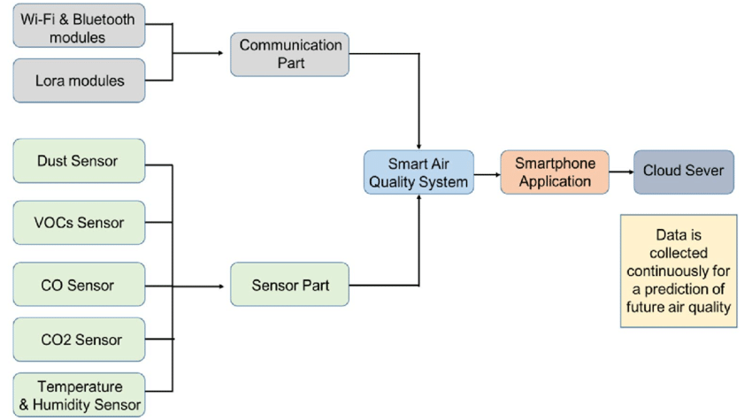Fig 1: Diagram of Air Quality Monitoring System

2.3 Literature Review Summary (Minimum 7 articles should refer)

|  |  |  |  |  |  |
| --- | --- | --- | --- | --- | --- |
| **Year and**  **Citation** | **Article/ Author** | **Tools/ Software** | Source | Evaluation parameter |  |
| **2009** | Anuj Kumar, I.P. Singh, and S. K. Sud | Sensors array, DSP (Digital Signal Processor), Semiconductor gas sensor, VOC (Volatile Organic Compound), SPM (Suspended Particulate Matter) | IMECS | **Success** |  |
| **2010** | A.R. l-Ali, Imran and Fadi Aloul, | Sensor Array, microcontroller | **IEEE** | **Success** |  |
| **2011** | Raja Vara Prasad Y, Mirza Sami Baig, Rahul K. Mishra, P. Rajalakshmi, U. B. Desai and S.N. Merchant, | **Wireless Sensor Networks (WSN), Gas Sensor Calibration** | **IEEE** | **Success** |  |
| **2018** | Samuel John and Kennedy | Internet of Things, Pollution, Air, Parts per Million, Quality and Metrics | IJCIET | **Success** |  |
| **2021** | Tuyen Phong Truong, Duy Thanh Nguyen, and Phong Vu Truong | Air quality monitoring, EnMoS, internet of things, LoRa technology. | **IJESD** | **success** |  |

# 3. PROBLEM FORMULATION:

The creation of a cutting-edge air quality monitoring system that surpasses the shortcomings of current methods and offers precise, real-time data on air pollutant concentrations is the issue this study attempts to solve. The objectives of this system are to increase spatial coverage, boost data accuracy and dependability, and facilitate improved comprehension and handling of air quality problems. By tackling these issues, the planned study aims to aid in the creation of more potent plans for reducing the damaging effects of air pollution on both the environment and human health.

# 4. OBJECTIVES

By Eliminating bad storage smell and helps in maintaining the environment fresh. Enhancing product quality and shelf life. Meeting NHB ventilation requirements.

The objectives of this project aims to create storage environments that are free from unpleasant odours, conducive to maintaining product freshness and quality, and compliant with relevant ventilation regulations and standards set forth by organizations such as the National Housing Board.

# 5. METHODOLOGY

A Temperature sensor is used to detect the pollution in the air only when the pollution is more and it exceeds the range then we get a beep sound. ∙ If the pollution in the air is less and is not exceed the range then we can't get any sound. ∙ A Rain sensor with nodes which doesn't collide with each other is placed in an area based on the temperature we get the values. ∙ Based on the humidity we can get the values through various sensors.

# 6.CONCLUSION

The smart way to monitor environment and air as well as sound pollution being a low cost but efficient and embedded system is presented in this paper. In the proposed architecture functions of different sensors and their working procedure were discussed. How they work, their functionality, their optimal uses and their data taking procedures and comparison with standard base data are also discussed here. The noise and air pollution monitoring system is tested for monitoring the gas levels on different parts of the country. It also sent the sensor parameters to the data server. Our project device showed that it is effective and cheap and with some highly working sensors it can really be a reliable one to everybody and its data’s will be a key to take some necessary steps for the betterment of the society as it will help to identify the affected area so that we can take early steps to reduce damages for the next generation.

## 8. TENTATIVE CHAPTER PLAN FOR THE PROPOSED WORK

**CHAPTER 1: INTRODUCTION**

* Background and significance of air quality monitoring
* Statement of the problem: importance of accurate air quality data
* Objectives of the study: to develop/improve an air quality monitoring system
* Overview of the structure of the paper

**CHAPTER 2: LITERATURE REVIEW**

* **Overview of existing air quality monitoring systems**
* **Discussion of key concepts in air quality monitoring (e.g., pollutants, sensors, data analysis techniques)**
* **Review of relevant studies on air pollution and its impacts**
* **Identification of gaps in current monitoring systems and research needs**

**CHAPTER 3: OBJECTIVE**

* Development of a theoretical framework for the proposed air quality monitoring system
* Explanation of key variables (e.g., pollutants, sensor types, data transmission methods)
* Discussion of relevant theories or models guiding the research

**CHAPTER 4: METHODOLOGIES**

* Description of the research design and approach
* Explanation of the hardware and software components of the monitoring system
* Details of sensor selection, calibration, and placement
* Data collection procedures and frequency
* Quality control measures and validation techniques

**CHAPTER 5: CONCLUSION AND FUTURE SCOPE:**

* Summary of key findings and contributions
* Importance of the developed system for addressing air quality challenges
* Recommendations for future research and practical applications
* Final reflections on the research process and potential impact

## REFERENCES

[1]Anuj Kumar, I.P. Singh, and S. K. Sud, “Indoor Air Quality estimation by Using Smart sensing System”, Proceedings of the International Multi-Conference of Engineers and Computer Scientists ,Hong Kong, vol.II, IMECS 2009, March 18-20, 2009.

[2] A.R. l-Ali, Member, IEEE, Imran Zualkernan, and Fadi Aloul, Senior Member, IEEE, “A Mobile GPRS-Sensors Array for Air Pollution Monitoring”, IEEE SENSORS JOURNALVOL.10, OCTOBER 2010.

[3] Raja Vara Prasad Y, Mirza Sami Baig, Rahul K. Mishra, P. Rajalakshmi, U. B. Desai and S.N. Merchant, “Real time wireless air pollution monitoring system”, ICTACT Journal on Communication Technology : special issue on next generation Wireless Networks and Applications, VOL.-2, ISSUE-2, JUNE 2011